1. Please create ERD for the flow above.

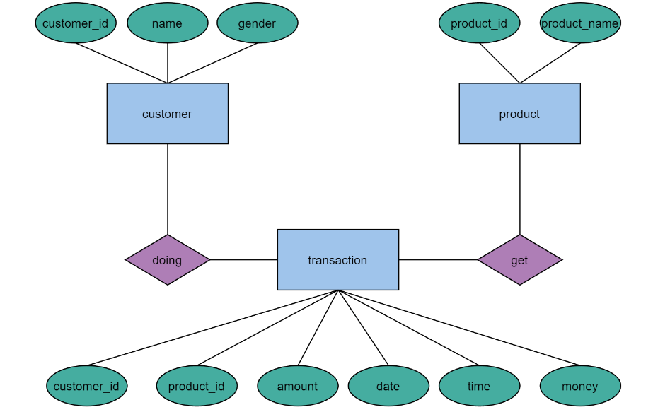

2. Please create query to **get best seller product for male and female**.

Select product_id, product_name, gender, max(amount) from product,transaction;

3. Please create query to **get customer that spends the most money.**

Select customer_id, name, max(money) from customer, transaction;

4. Please create query to **show number of transactions for every 2 hours.**